CE 2710 Final Exam Study Guide
Fall 2020

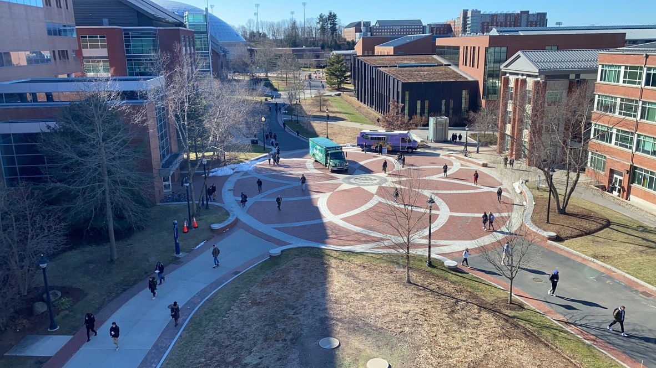

Evolution of Transportation
- Understand the definition of transportation as being about access not mobility
- Know the main milestone and approximate dates in the history of USA transportation (for freight, intercity travel and urban travel)

Transportation Today
- Understand the differences between transportation infrastructure and transportation policy
- Know how specific transportation policies might affect peoples use of transportation
- Know the typical modes of freight transportation
- Know the typical modes of intercity transportation
- Know the factors that influence the choice of intercity mode
- Know the factors contributing to higher train use for intercity travel in Europe versus America

Urban Transportation
- Understand the role of transportation and transportation technology in the evolution of the urban form (The '30-minute' commute)
- Know the typical types of modes of urban transportation
- Understand why walking is considered the most important mode of transportation in a city
- Understand the advantages of a multimodal transportation system and the complications involved in providing such a system
- Understand the factors affecting mode choice
- Understand the differences between the different types of urban rail systems – including differences in location of tracks and in typical operating conditions
- Know the definition of bus rapid transit; Understand why BRT was developed; The pros and cons of BRT; The features that are used to make BRT more competitive with rail
- Know in general terms the characteristics of a good transportation system

Transportation and Land Use
- Understand the nature of the two-way interaction between transportation and land use; Understand in general terms how this interaction affects transportation planning
- Know the specific features of transportation that affect land use and the general nature of this relationship
- Know the specific land use factors that affect transportation use and the general nature of this relationship
- Understand the meaning of the term Transit Oriented Development
- Understand the transportation and land use factors that affect the walkability of an urban area

Transportation Planning
- Know the main principles of a comprehensive transportation planning effort as compared to traffic based planning
- Know the different geographic and temporal scale over which transportation planning is undertaken
- Understand the concept of induced traffic
- Understand Littman’s three levels of transportation planning impacts and how this relates to induced traffic
- Understand the differences between ‘access’, ‘mobility’ and ‘traffic’
- Know the difference between ‘goals’ and ‘objectives’ and why the difference is important

Transportation Forecasting
Overview
- What is the 4-step process and what is it used for?
- What are the steps and the purpose of each of the 4 steps?

Trip Generation
- What is the purpose of trip generation?
- Know the format of the cross-classification TG model
- Know in very general terms the procedure used to get a TG model?
- Know what land use and socio-economic factors are generally considered?
- Know why is it necessary to consider land use and socio-economic factors?
- Know how to use the cross-classification TG model to calculate number of trips from a TAZ
- Understand the potential sources of error in the TG process

Trip Distribution
- What is it?
- Describe gravity model - the parameters and the meaning of the parameters
- Know how to use gravity model to get trip interchange
- Know the limitations of the gravity model

Modal Split
- What is it?
- What is a utility function?
- Know the parameters typically used in the utility function
- Know how factors such as comfort and image are considered in the model
- Know how to use the utility function and logit model to get modal split

Trip Assignment
- What is it?
- Know how the network is represented?
- Know how to interpret network graph, link table and link array
- Know what a tree diagram is
- Know how to determine tree diagram from network graph or link array
- Know how to interpret a tree table
- Know the meaning of the term ‘all-or-nothing’ assignment
- Know how to use tree diagram and 'all-or-nothing' assignment to assign trips to links

Traffic Flow
- Know and understand the relationship between i) spacing and concentration, ii) headway and flow
- Know the definition and equations for determining time-mean-speed and space-mean-speed
- Know where to use TMS versus SMS
- Know how to construct and use the time-distance diagram to get spacing, headway, flow, concentration and speed
- Understand how vehicle spacing changes with speed
- Know the relationships between flow, speed and concentration
- Know the general shape of the speed-concentration, speed-flow and flow-concentration diagrams
- Understand why slower speeds might result in higher flow
- Understand the concept of a shock wave – how it forms and under what condition
- Know the procedure and formulas to analyze the propagation or dissipation of shock waves

Traffic Data
- Know, in general, how traffic volume can vary in time and space and the factors contributing to this variation
- Understand how temporal and spatial variations in traffic volume affect the design
- Know how non-design approaches can help to deal with the inefficiencies caused by temporal variations
- Know what directional distribution is; what factors contribute to it and how it affects design
- Understand the relationship between land use type and directional distribution
- Understand, in general, how traffic is counted and by whom

Street Capacity
- Know the definition of AADT
- Know the basics of how the state collects data to calculate AADT
- Know why AADT is not sufficient information on which to base design decisions
- Know how a design hour is selected and the trade-off involved in choosing a design hour
- Understand how to interpret and use the AASHTO (or similar) chart for estimating design hour volume from the AADT
- Understand the concept of Level of Service and its relationship to capacity or DHSV
- Know the trade-off involved with using different LOS
- Know how to calculate the number of lanes for a road based on DHSV and DHV
- Understand the problems associated with 'predict and provide' planning and how ‘predict and provide’ is related to estimating DHV

Alignment Design
Horizontal Alignment
- What are the elements of the horizontal alignment?
Circular Curve
- Know how to sketch a circular curve and to label the key locations.
- Know the definition of degree of curvature (D).
- Know the difference between degree of curvature and external angle (DELTA).
- Know how to derive the relationship between R and D.
- Know how to derive the relationship between L and R.
Spiral Curve
- What is the purpose of the spiral curve?
- What are the basic properties of the spiral curve?
- Know the definition of the 'k' value for the spiral curve.
- Know the relationship between the lengths (and the central angle) of the spiral and circular legs in a spiral/circular composite curve.
- Know how to use the equations for calculating length of curves and DELTAS

Vertical Alignment
Parabolic Curve
- Know how to sketch a parabolic curve and to label the key locations.
- Know the difference between sag and crest curve.
- Know the definition for the rate of change of curvature parameter (K).
- Know how to calculate A.
- Know the definition of the rate of change of grade (r).
- Know how to determine the grade at each point on a vertical curve.
- Know how to determine station and elevation of the turning point.
- Know how to determine elevation at all locations on a vertical curve.

Designing 3-D Alignments

Know how to produce and interpret a 1/R Plot.
- Know the definition of a continuous alignment
- Know and understand the 4 steps for producing a continuous 3-D alignment.
- Know how the 1/R Plot can be used to assess these 4 steps for producing a continuous 3-D alignment.

Urban Street Design

Understand the changes in the philosophy of street design in terms of the priority given to different types of road users

Know in general terms the relative amount of space occupied by different modes of travel for moving 50 people
- Know and understand the 3 essential elements for the design of urban street design
- Understand what a connected street network looks like
- Understand why walkers and bikers are considered vulnerable street users in America (but perhaps not so much in the Netherlands)
- Understand the role of speed for safety and convenience of different class of road users
- Know the main factors that are important in designing for vulnerable road users
- Know the characteristics that distinguish system time street design from context time design
- Understand why context time design is the more suitable approach for urban street design
- Know the main features of the street, building and site design that help to create a sense of place

Roundabouts
- Know in general the history of circular intersections
- Know the difference in design and operations between roundabouts and tradition traffic circles or rotaries
- Know the difference in design, operations and use between roundabouts and neighborhood traffic circles
- Know the purpose, design and function of neighborhood traffic circles
- Know the pros and cons of roundabouts vis-à-vis conventional intersection types
- Know the theory relating to speed and conflict points that contribute to roundabouts being safer than other types of intersections.
- Know the basic design elements of a modern roundabout.
- Know the approximate size of the inscribed circle for different classes of roundabouts.
- Know how the individual design elements affect vehicle speed and operations
- Know the different ways that pedestrian and bike traffic are handled in roundabouts
- Understand the main difficulties that may affect visually impaired people in using a roundabout
- Know the main strategies that are used to better accommodate visually impaired users at roundabouts

Bike Facility and Bike Network Design
- Know the range of bike mode share in cities in USA and how the USA compares internationally
- Know how use of bike have changed over time in US cities
- Know the four type of bike facility types discussed in class and their general design characteristics
- Know the general conditions under which each type of bike facility should and should not be used
- Know the typical dimensions for bike facilities
- Know the design conditions for avoiding dooring
- Understand the concept of a bike boulevard and the strategies that have been used to create a network of bike boulevards
- Know the general guidelines for the frequency of bike routes needed to create an effective network
- Understand the operations of a bike box

Formulae Given on Exam

Gravity Model
Q_{IJ} = P_{I} (A_{J}*F_{IJ}*K_{IJ})/ Σ(A_{J}*F_{IJ}*K_{IJ})

Multinomial Logit Model
p(k) = e^{uk} / Σ e^{uk}

Shockwaves
Time until queue or platoon dissipate
T = t u_{sw2} / (u_{sw2} - u_{sw1})

Circular Curves

R = 5730/D

L = (R Δ /57.3)

Spiral Curves

k = 100 D/ L_{s}

Δ_{s} = L_{s} D / 200

Δ = Δ_{c} + 2 Δ_{s}

Parabolic Curves
y = yo + g1 x + r x2/2

r = (g2 - g1)/L

xt = - g1 / r

K = L / | G₂ - G₁ |

